caXchange using Servicemix
Design Document

Version No: 0.1
Last Modified: 10/11/2007

Author : Kalpesh S. Patel
Team : caXchange

Client : National Cancer Institute - Center for Bioinformatics,
National Institutes of Health,
US Department of Health and Human Services

Document History

Document Location
The most current version of this document is located in CVS.

Revision History
Version Number | Revision Date | Author | Summary of Changes
0.1 | 12/17/07 | Kalpesh S. Patel | Initial draft

Review
Name | Team/Role | Version | Date Reviewed | Reviewer Comments

Related Documents
More information can be found in the following related documents:
Document Name
caCORE 3.2_Tech_Guide (Chapter 10: Common Logging Module)
CSM – User Provisioning Tool User Guide (ftp://ftp1.nci.nih.gov/pub/cacore/CSM/UPT_User_Guide.pdf)
Servicemix Documentation
http://servicemix.apache.org/documentation.html
caXchange Interface Specification
caXchange Design Diagram
Java Business Integration Specification

Table of Contents
1. Introduction 4
1.1 Purpose 4
1.2 Scope 4
2. Component View 4
3. Logical design 5
3.1 caXchange Grid Service 5
3.2 caXchangeResponse Listener 5
3.3 caXchange Service Assembly 6
3.4 Sequence Diagrams 7
3.4.1 Successful flow Sequence diagram 7
3.4.2 Rollback Flow Sequence Diagram 8
4. Data 9
5. Deployment 10
6. Test Cases and Scenarios 11

Introduction

The caXchange is defined as the software component that is primarily responsible for receiving input from various external systems, routing the input to various services that are hosted on the hub, and eventually routing the output of those services to external systems. caXchange is implemented using Servicemix 3.1.2 enterprise service bus (ESB) for routing and exposing that functionality using a service deployed on caGrid. caXchange is deployed as a service assembly on Servicemix 3.1.2. caXchange grid service acts as a proxy to the service assembly.

Purpose
The purpose of this document is to document the design of caXchange as it is developed and deployed on Servicemix 3.1.2.

Scope
The scope of this document is limited to the design of caXchange.

Component View
Figure 2-1
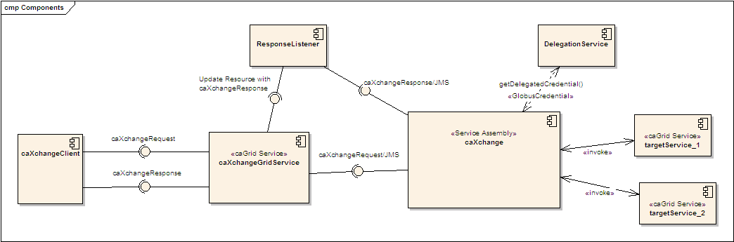

This shows the high level components in caXchange. Please refer to the caXchange design diagram for the components within the caXchange service assembly.
A caXchange client sends a caXchangeRequest message to caXchangeGridService.
caXchangeGridService is a caGrid service which acts as a proxy for the caXchange service assembly deployed on Servicemix JBI(Java Business Integration) Container.
caXchangeGridService creates a WS-Resourceframework Resource associated with the caXchangeRequest. This caXchangeRequest is then forwarded to the caXchange service assembly for processing. This is done by pushing caXchangeRequest message to the jms inbound component of caXchange service assembly.
caXchange service assembly then invokes the DelegationService for the authorization credentials before routeing the request message based on the message type. Please refer to the caXchange detailed design diagram for routing details.
Outbound components then invoke the target services.
Responses from the target services are then composed into a caXchangeResponse message.
caXchangeResponse is then pushed to the jms outbound component.
Response listener then picks up the caXchangeResponse and updates the WS-Resourceframework resource created in step 3.
The caXchangeResponse is then available to the client.

Logical design

caXchange Grid Service

caXchange grid service acts as a proxy for caXchange. It forwards incoming requests to caXchange for processing. To keep track of a request it creates a WS-Resource framework resource. The grid service then returns an EndPointReference to the client. The client uses this end point reference to invoke the getResponse operation. The grid service also creates a response listener, which listens for caXchangeResponse and updates the resource. Please see the caXchange interface specification document for details of the operations it exposes.

Operations

Method | Notes | Parameters | Return
ProcessRequestAsynchronously | Process a caXchangeRequest | CaXchangeRequest | CaXchangeContextReference
getResponse | Gets the caXchangeResponse if it is ready, otherwise throws an Exception | None | caXchangeResponse

caXchangeResponse Listener

The caXchangeResponse listener lives with the caXchange Grid service. It listens for the response on the jms queue associated with the response outbound component of the caXchange service assembly. Once a response is received from the queue, the resource associated with the corresponding request is updated. The client can then use the getResponse method to get the caXchangeResponse.

Fig 3.1

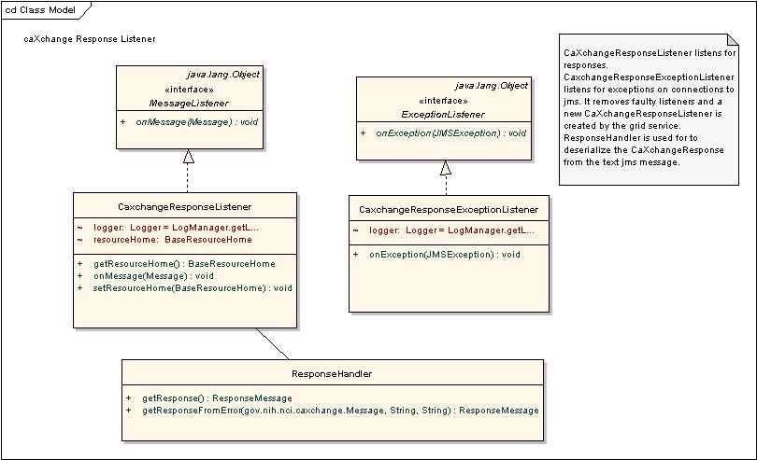

caXchange Service Assembly

caXchange service assembly is deployed on the Servicemix JBI container. The caXchange design diagram gives the detailed design of the caXchange service assembly.

The following table describes caXchange service assembly component. Numbers in the component column refer to the number in the caXchange design diagram given to an exchange going into that component.

Component | Type | Purpose
1.InboundComponent | JMS | Receive inbound caXchangeRequest messages.
3. Invoke Delegation Service | Bean/EIP (Enterprise Integration Patterns) | This includes two components, a pipeline, which invokes a bean component that calls delegation service for authentication and authorization.
3.3/4.3 Response Generator | Bean | Generates an error response
4.Save Message | Bean/EIP | This includes two components, a pipeline, which invokes a bean component that saves the message to a database. The saved message is used to contruct a response and/or sends a rollback.
5. Content Based Router | EIP | Routes the message based on the message type to a particular static recipient list.
6. Static Recipient List | EIP Customized | Sends the message to multiple recipients for invoking target services. This is customized to add a message property for number of recipients. This is used to aggregate responses
7. Content Based Router | EIP | Routes message based on operation. If the operation is process the message is routed to a pipeline to invoke the service and get a response as an in-out message exchange. If the operation is rollback the message is send without expecting a response as an in-only message exchange.
8.1 Pipeline | EIP | Pipeline to invoke target service as an in-out message exchange.
8.2 Outbound Component | Bean | Outbound component that invokes the target Grid Service.
8.4 Aggregator | EIP Customized | Aggregator component aggregates responses from multiple target services. This is customized to work with the customized static recipient list in #6 above.
9 Aggregator Listener | Bean | Aggregated responses from the aggregator are forwarded to this component, which does two things.  - It looks at the response and the message type to verify if a rollback is required. If required a message with the rollback is sent to the content based router #5 after authentication and authorization by #3.  - It creates a caXchangeResponse and sends it to the jms outbound binding component.
10.ResponseComponent | JMS | Outbound caXchangeResponse are pushed to this component.

Sequence Diagrams

Successful flow Sequence diagram
Sequence for a successful flow through caXchange is depicted below. Detailed flow through the caXchange service assembly is depicted in the caXchange design diagram.

Fig 3.2

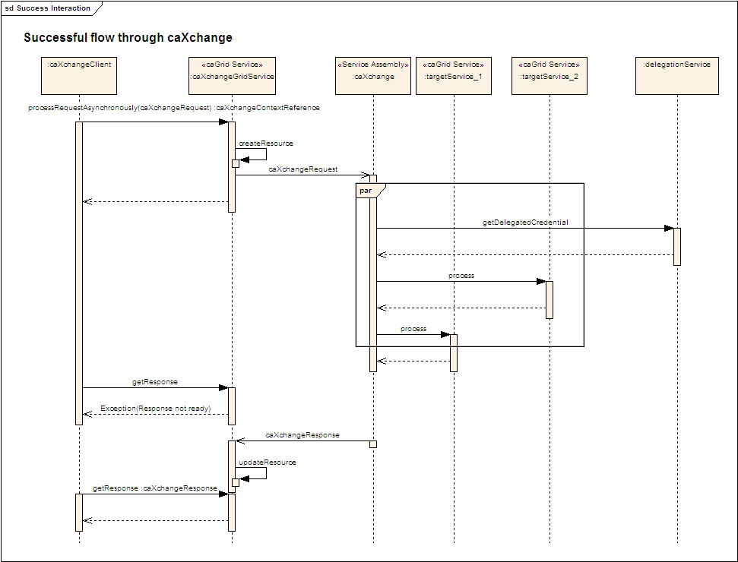

Rollback Flow Sequence Diagram
Sequence for a rollback interaction with caXchange is depicted below. Detailed interaction withing caXchange service assembly is depicted in the caXchange design diagram.

Fig 3.3
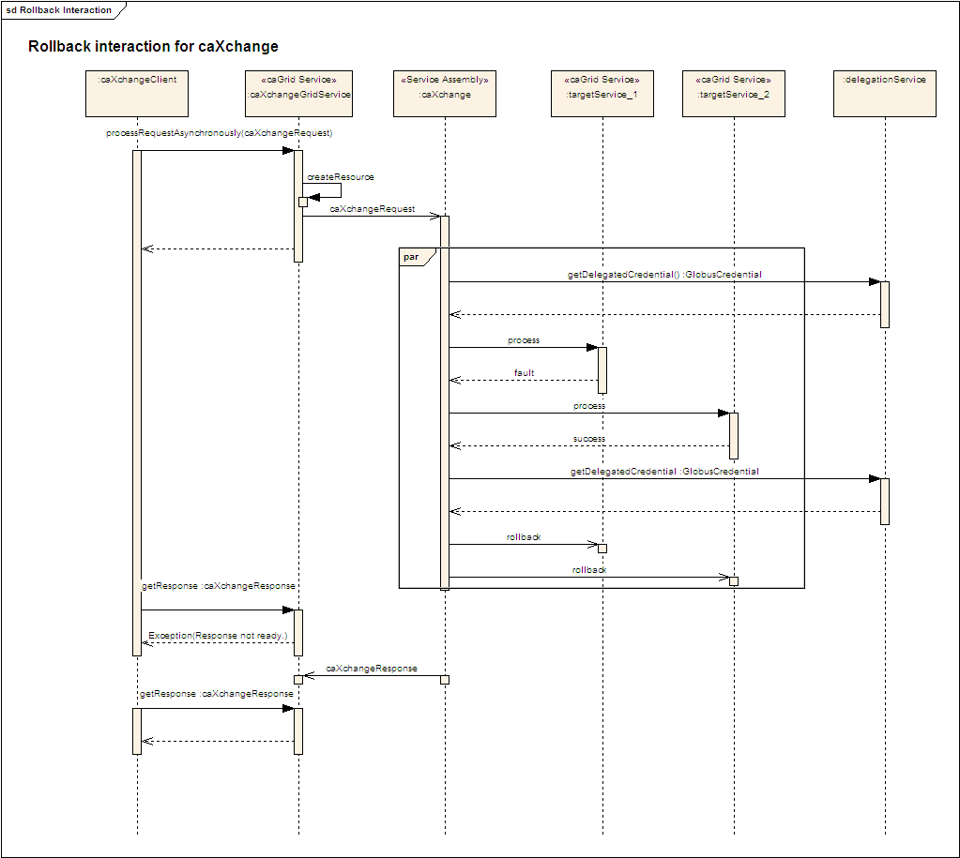

Data

Database schema would be created to facilitate saving the inbound caXchange request message for sending rollbacks and for creating aggregated/error responses.

Fig 4.1

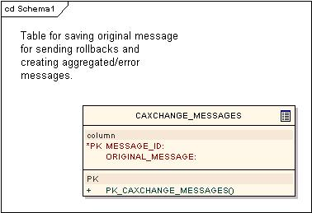

Deployment
Fig 5.1
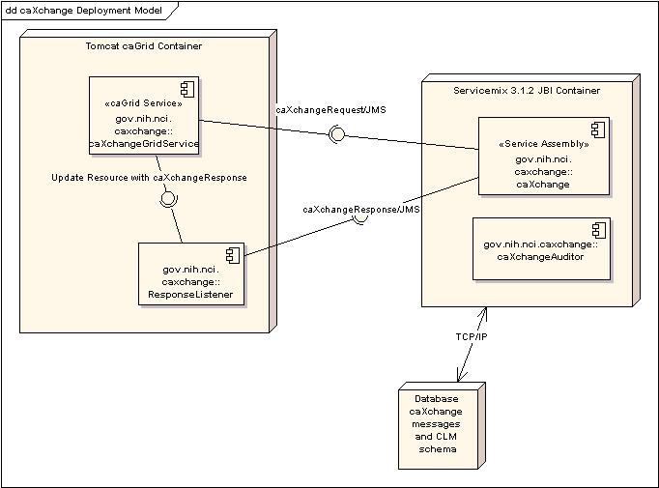

Test Cases and Scenarios
Please refer to the caXchangeTesting Approach Document for test cases.

caXchange Interface Specification.
caXchange Interface Specification

